**EXPERIMENT NO:-7**

**AIM:**

To familiarize with Group by and having clause

**PROCEDURE:**

1. List the branches having sum of deposit more than 5000.

SELECT BNAME, SUM(AMOUNT) AS TOTAL_DEPOSIT FROM DEPOSITE GROUP BY BNAME HAVING SUM(AMOUNT) > 5000;

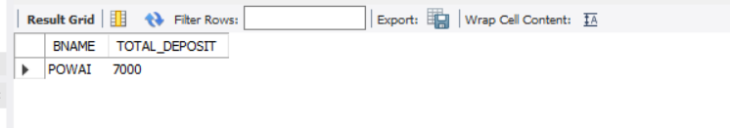

1. List the branches having sum of deposit more than 500 and located in city BOMBAY

SELECT BNAME, SUM(AMOUNT) AS TOTAL_DEPOSIT FROM DEPOSITE WHERE BNAME IN (SELECT BNAME FROM BRANCH WHERE CITY = 'BOMBAY')GROUP BY BNAME HAVING SUM(AMOUNT) > 500;

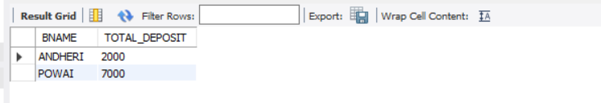

1. List the names of customers having deposited in the branches where the average deposit is more than 5000.

SELECT DISTINCT CNAME FROM DEPOSITE WHERE BNAME IN (SELECT BNAME FROM DEPOSITE GROUP BY BNAME HAVING AVG(AMOUNT) > 5000);

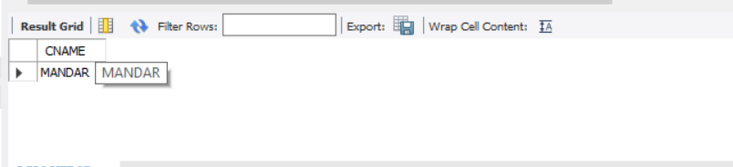

1. List the names of customers having maximum deposit

SELECT CNAME, MAX(AMOUNT) AS MAX_DEPOSIT FROM DEPOSITE GROUP BY CNAME ORDER BY MAX_DEPOSIT DESC LIMIT 1;

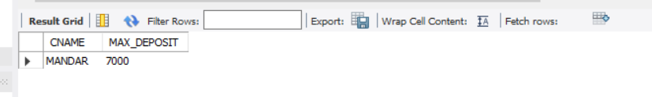

1. List the name of branch having highest number of depositors?

SELECT BNAME, COUNT(DISTINCT CNAME) AS NUM_DEPOSITORS FROM DEPOSITE GROUP BY BNAME ORDER BY NUM_DEPOSITORS DESC LIMIT 1;

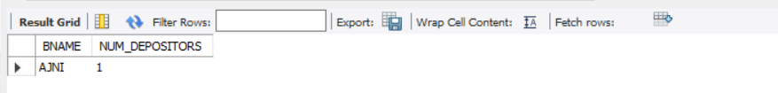

1. Count the number of depositors living in NAGPUR.

SELECT COUNT(DISTINCT CNAME) AS NUM_DEPOSITORS FROM DEPOSITE WHERE BNAME IN (SELECT BNAME FROM BRANCH WHERE CITY = 'NAGPUR');

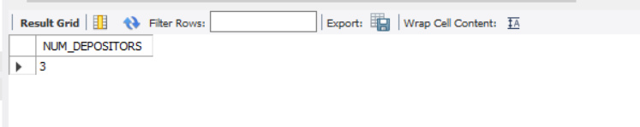

1. Give names of customers in VRCE branch having more deposite than any other customer in same branch

SELECT CNAME FROM DEPOSITE WHERE BNAME = 'VRCE' AND AMOUNT = (SELECT MAX(AMOUNT) FROM DEPOSITE WHERE BNAME = 'VRCE');

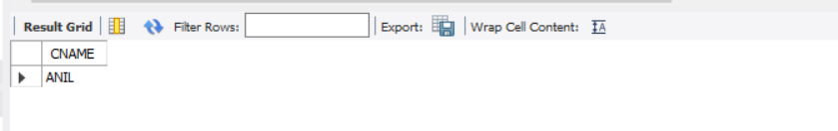

1. Give the names of branch where number of depositors is more than 5

SELECT BNAME FROM DEPOSITE GROUP BY BNAME HAVING COUNT(DISTINCT CNAME) > 5;

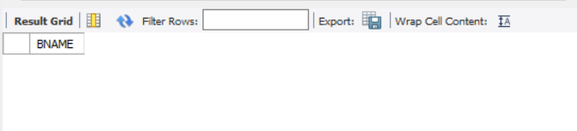

1. Give the names of cities in which the maximum number of branches are located

SELECT CITY, COUNT(*) AS NUM_BRANCHES FROM BRANCH GROUP BY CITY HAVING COUNT(*) = (SELECT MAX(NUM_BRANCHES) FROM (SELECT COUNT(*) AS NUM_BRANCHES FROM BRANCH GROUP BY CITY) AS TEMP);

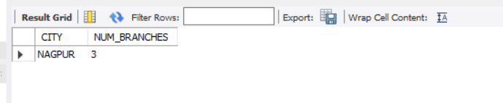

10.Count the number of customers living in the city where branch is located

SELECT COUNT(DISTINCT CNAME) AS NUM_CUSTOMERS FROM DEPOSITE WHERE BNAME IN (SELECT BNAME FROM BRANCH WHERE CITY = 'CITY_NAME'); 